«TriangleMX» FFGL Mixer

# Introduction

This short paper contains TriangleMX FFGL-mixer plugin usage info. TriangleMX mixer combines two video layers using triangle mesh pattern. The screen area is divided into two triangle strips and every triangle is textured with curtain input layer, as shown in the diagram:

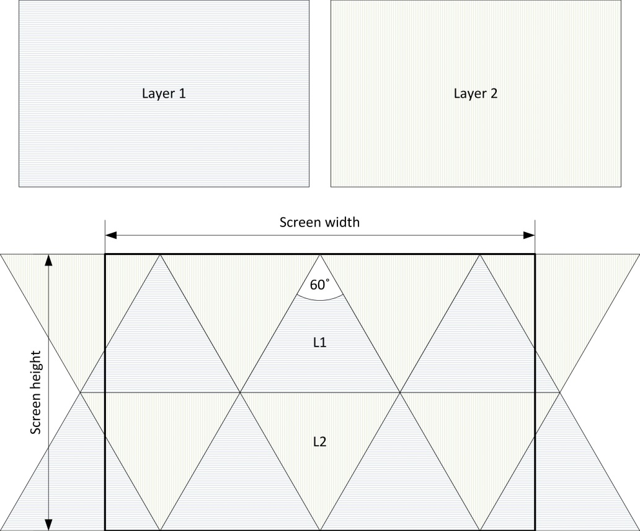

Blending factor controls texture mapping for different triangles (as demonstrated later).

# Installation

Putting plugin dll-file into Resolume 4.x.x video effects directory is the only required operation. Normally, the suitable location is something like that - «C:\Program Files (x86)\Resolume Arena 4.X.X\plugins\vfx». If the things are okay, you should see mixer in the blending mode list:

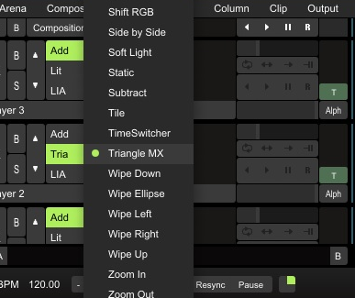

# Plugin usage

Here are some examples of plugin usage. As input data we consider two simple images (generated by «Lines» source plugin). First layer is a stack of horizontal lines and second one is composed of vertical lines:

|  |  |
| --- | --- |
| **Layer 1**: | **Layer 2**: |

Mixing with blending factor 0.01 – input images are divided in the same manner as screen area.

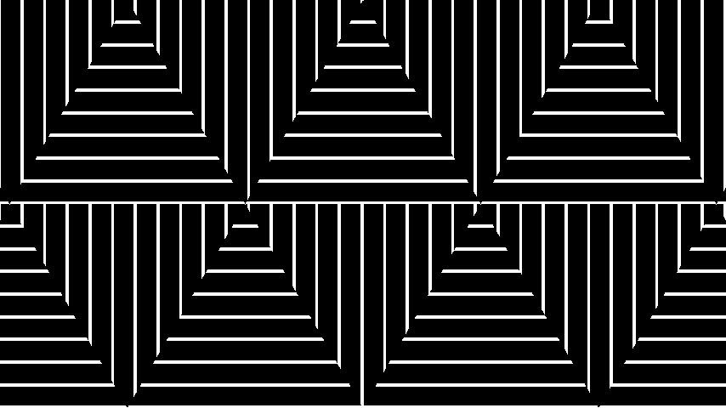

Mixing with blending factor 0.26 – input images are fitted «by height» into central triangles.

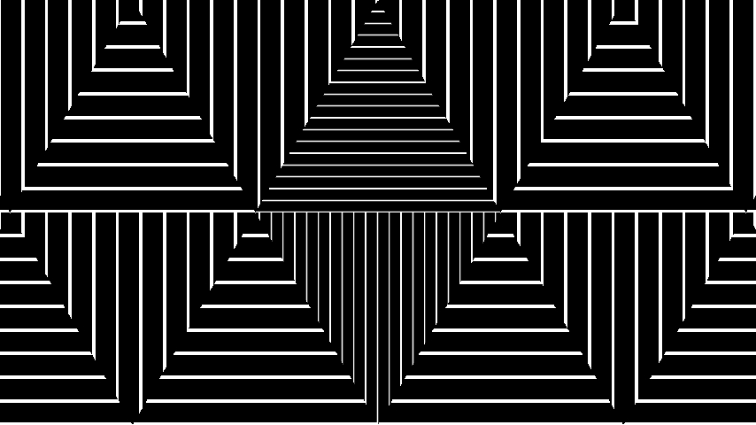

Mixing with blending factor 0.51 – input images are fitted «by height» into six central triangles.

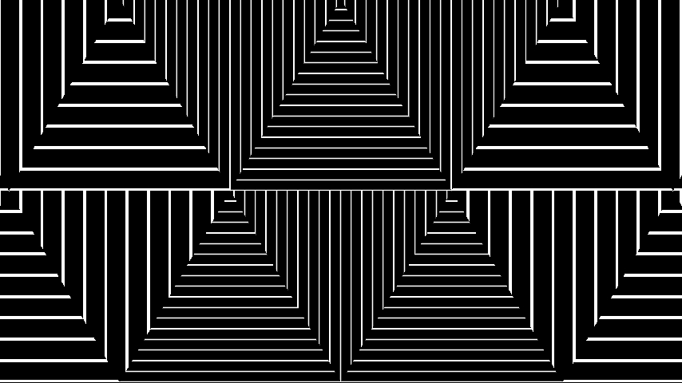

Mixing with blending factor more than 0.77 – input images are fitted into all triangles.

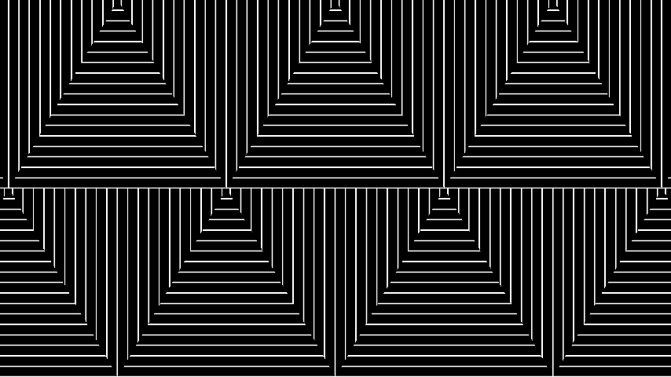

Additional demos available here <http://vimeo.com/85140944>, <http://vimeo.com/84898044>.

# Credits

The idea of the mixer was condensed from Vadim Epstein (vj Eps) demo «Secret in their eyes» (<https://vimeo.com/63057090>).